The double constraints of convention and cognition in successful graphic design

Or the new title, but I am not sure if I can change it for the Brazil conference:

Cognition, context, and convention in effective graphic design

Pino Trogu DRAFT: 16/06/2013 9:00 pm
cognition, context, convention, shared knowledge, working memory

This paper proposes an historicist view of graphic design that affords students and practitioners a better theoretical alternative to the predominant but insufficient model based on structuralism and semiotics. The limitations of graphics as a formal, monosemic system are discussed with reference to the psychological insights of art historian Ernst Gombrich. These limitations can be overcome if cognitive psychology's understanding of perception, memory, and learning are actively taken into account. The paper discusses cognitive science's description of the stringent time limitation – consisting of just a few seconds – imposed by working memory on any act of perception. While this limitation cannot be forced, the designer can employ flexible cultural conventions to minimize its adverse effects. The paper describes how in working memory, the verbal is as important as the visual, and how this duality should be considered even when designing a "mute", visual artifact such as a poster. Three important concepts related to convention and context are discussed: 1. Shared knowledge, culturally based and not universal; 2. Polisemy or multiple sign meanings within genres; 3. Perception as construction. Visual examples, including 1972 and 1979 subway maps, and an 1869 historical map are used to illustrate the key concepts of the paper.
1 A beautiful design that did not work
In 1972 the New York City Transit Authority introduced a beautiful map of its subway system that was radically different from previous ones. Inspired by Henry Beck’s geometrical London Underground map of 1931, it was introduced after the NY subway system had implemented a large subway renovation project. But just seven years later, in 1979, after many complaints from confused subway riders, the 1972 map was discontinued and a new one issued, with a design that has survived to the present day basically unchanged. (Loyd & Ovenden, 2012)
The 1972 map was by the Italian designer Massimo Vignelli of Unimark International, and is often seen by purists as a monument to modernism, a graphic nod to abstract art, and a model of simplicity, with its clean, bright-colored lines admitting only verticals, horizontals, and forty-five degree angles. The map is indeed a beauty to behold, a designer’s counterpoint to Mondrian’s playful painting Broadway Boogie-Woogie.
Figure 1: The New York Subway map designed by Massimo Vignelli in 1972. Dim. 18" x 22", Source: Author, 2012.
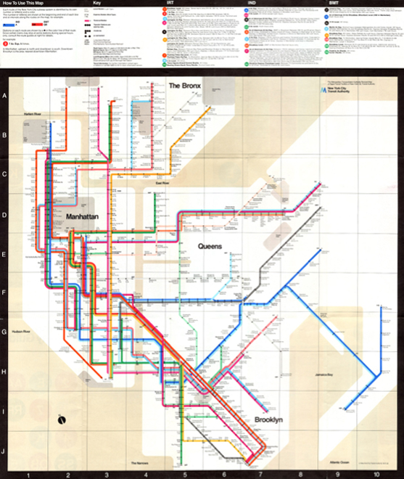
Figure 2: Piet Mondrian, Broadway Boogie-Woogie (1943) oil on canvas, dim. 50" x 50", Museum of Modern Art, New York.
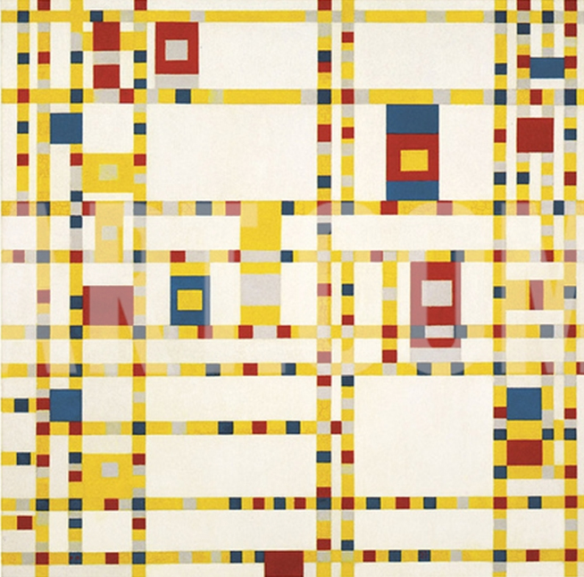

By contrast here is its more complex replacement, which, with modest changes, has satisfied subway riders for the past 33 years:
Figure 3: The New York Subway map from 2012, based of the 1979 redesign by Michael Hertz. Source: MTA, New York City, 2012..
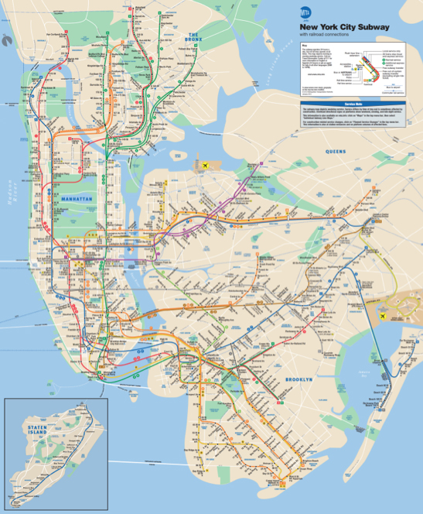

If the success of a graphic at a minimum requires communicative effectiveness, then we have to concede that the Vignelli attractive effort was a failure, whereas its more detailed replacement has been an ongoing success for a third of a century. In this paper, I’ll try to explain rather fully why the beautiful Vignelli failed and why its replacement has succeeded.
I’ll apply some principles gleaned from art history, linguistics, and, above all, from cognitive psychology. My broader goal is of course much more general than offering a critique of Vignelli. I shall attempt to analyze some more general underlying reasons for communicative success and failure in the world of graphic design. My aim isn’t of course to propose a formula for communicative and aesthetic success. Quite the contrary, I will argue that immediate contextual considerations are central to effective design.
Ad hoc-ness is a quite general principle, because of the cultural particularity of viewer responses within a defined cultural and historical context. This is a view that conforms more with the historicist tradition in art history – as represented by Edgar Wind and Ernst Gombrich – than with the structuralist tradition represented by the influential French cartographer and information visualization theorist Jacques Bertin. As a fine practitioner, Bertin is often a useful guide despite the shortcomings of his structuralist theory, which holds that graphic design (graphics) uses an armory of “monosemic” signs. (Bertin, 1983)
This word “monosemic” should be a warning signal to anyone steeped in art history, where no visual form is monosemic. A form is not even a definite form or shape as such until it is interpreted by an audience within an historical context. Bertin belongs to the structuralist tradition of “semiology,” founded upon the brilliant linguistic analyses of Ferdinand de Saussure, whose work is a permanent contribution in its explanation of the phonological structure of language, (de Saussure, 1959) but inadequate in its account of linguistic communication, which is never fully constrained by the outward forms of language. For example, form by itself cannot be used to determine whether a written sentence is ironic or not. If fact it is meaning (is it or is it not ironic?) that modifies the form, and not the other way around.
Yet communication is the primary function of graphic art. Gombrich, steeped in the technical literature of the psychology of perception is the better guide to graphic artists. He pointed out that there is no pre-interpretive given in the linguistic or the visual world – except perhaps the human face and smile to which infants readily respond at birth.
My chief aim will be to bring together some insights that have grown out of both art history and recent cognitive science. Some of these fundamental principles were well discussed by Gombrich, who was expert in the psychology of his time. But since the era of Art and Illusion and his other masterpieces, (Gombrich, Art and Illusion: A Study in the Psychology of Pictorial Representation, 1960) cognitive science has yielded further fundamental insights, especially those regarding the function and limitations of working memory – a narrow, unstable territory through which all conscious mental activity must pass. A greater awareness of these recent insights may help design teachers and practitioners become more effective. They have certainly helped me both in my teaching and my practical work.
In this essay, constrained by length limits, my focus will be less on the aesthetic than on the communicative task of graphic design – though communicative closure and aesthetic pleasure are deeply connected psychologically. (Butter, 2011)
2 The peephole of working memory
It’s been useful in cognitive research to think of the mind as containing two main cognitive modules – working memory and long-term memory. Working memory is a stern disciplinarian. ‘Information is only held in working memory from between one-tenth of a second and, at most, a few seconds, and it is only held to support some ongoing cognitive process.’ (Ware, 2008: 115) This temporal constraint is constantly imposing itself whether the process concerns a linear fixed sequence as in a verbal text, or a non-linear, flexible-sequence in perceiving a visual image. A simple way to think of working memory says D. Willingham is to define it as the ‘site of awareness and of thinking’ and he describes long-term memory as a ‘vast storehouse in which you maintain your factual knowledge of the world’. (Willingham, 2009) In this larger, more stable depository we store both concrete facts (the date on one’s wedding) as well as abstract ones (a square has four sides) and also procedural information (how to tie your shoe laces).
When people look at a graphic their perceptual activity in working memory is being recycled every few seconds trying to achieve closure, as all the while the narrow window constantly moves forward in time. If meaningful closure among the visual items is not reached in a second or two, some items will fall out of memory, and the process must be restarted. The ephemeral nature of this very small window of time is a key fact that should be taken to heart by the conscientious designer: Time is precious in processing any part of a graphic. Unless the mind reaches meaningful closure quickly, confusion is the result, as the New York subway riders complained when trying to use Vignelli’s map. Key elements of Vignelli’s design kept receding from their working memories, and the process had to begin again.
***
‘My problem is that I have been persecuted by an integer.’ So began a 1956 essay by George A. Miller entitled “The magical number seven, plus or minus two: some limits on our capacity for processing information”, an essay that marked a milestone in psychology. Ever since Miller’s essay, the terms “immediate memory,” “short-term memory,” and now “working memory,” defined some of the most illuminating and rewarding research programs in the history of psychology. Miller found that we can never keep more than about seven “chunks” (Miller’s word) of information in our immediate memory at the same time. This justifies his use of the work “chunk.” For if you can chunk the items – for instance the digits in your social security number – your “tax” number – then you can remember that number more readily. That’s why social security numbers are written in chunked groups: 434-65-9623. Here we have 8 digits but just 3 chunks, making the number much easier to handle and recall than 4-3-4-6-5-9-6-2-3.
If speed of processing is the key to the mechanism of working memory, then quick, meaningful closure is critical. But what is “meaningful closure”? In language it is enhanced by simple as well as complex means. At the simplest level, phrases and paragraphs can be collapsed into non-temporal chunks that can be processed faster. A series of random three letter sequences – CFP, NHI, NDB – will be harder to remember than a similar sequence of familiar three letter acronyms: CNN, PHD, FBI (Willingham, 2009) because each of those combinations is already known as a kind of word. And indeed words are the prime examples of meaningful elements, for which there are many analogies in graphic design.
An explicit concept such as a word, a name, or a phrase, always represents a much larger set of implicit meanings (Hirsch, Jr., 1977: 124) with which the reader may be more or less familiar. James Bond for instance:
Figure 4: Double O Seven, beautiful women, guns, and gadgets are some of the implicit meanings represented by the explicit concept James Bond. Comic book cover from 1969. Zig Zag magazine, issue 5 & 6.
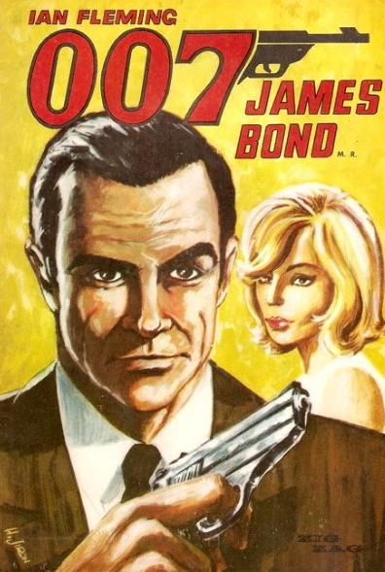

A small part therefore can always refer to a larger whole and represent it appropriately. This was an insight regarding the concept of representation that was best explicated by the German philosopher Ernst Cassirer who in the introduction of his book The Philosophy of Symbolic Forms describes representation as a psychological principle that is fundamental to the process of thought (Cassirer, 1953: 93-105). We now know why. It’s because we have a very narrow window of attention, and must therefore compress elements by symbols, synecdoches, metaphors, and names, in both the visual and linguistic domains. Miller’s work has explained and confirmed Casssirer’s.
Modern psychology has refined Miller’s insight, reducing the average number of items as closer to four than to seven. More important, it has found that the real limitation on our “site of awareness” is determined less by an item limit than by a ruthlessly imposed time limit for unifying separate and distinct items before they drop out of awareness. For example, it’s been found that Chinese students doing mental math can keep in mind more integers than American or European students can, in part because the number words in Chinese have fewer syllables, and hence take a shorter time to process. (Geary, Bow-Thomas, Liu, & Siegler, 1996)
3 The duality of working memory: the verbal and the visual
Alan Baddeley, who has conducted memory research for several decades, has developed a well-accepted model of working memory that consists of two basic components. (Baddeley, 1999: 49-66) One is the articulatory or phonological loop, that provides a temporary verbal storage, even in the case of visually presented materials. He found that we unconsciously name objects as they are presented in a process called “sub-vocalization” – a kind of inner speech. It’s been shown since the 1970s that we subvocalize when viewing pictures. (Noizet & Pynte, 1976) Such naming plays a strong role for gaining rapid closure in the successful perception of a visual organization, just as it does in the understanding of a verbal organization. (Logie, 1996)
The other component of working memory, is the visuo-spatial sketch pad involved in temporary retention of visual and spatial information. ‘As the phonological loop has been linked to the speech system, the visuo-spatial sketch pad has been linked to the control and production of physical movement.’ (Logie, 1996: 53) The tight visual-verbal interaction that takes place within the process of working memory suggests a distributed effort among all the components of the system, especially between the phonological loop and the visuo-spatial sketch pad. And here’s a key point for designers: the role of the verbal seems to be just as important as the visual in processing visual information. Quick recognition of representations is connected with quick naming of them – a feature that can be reinforced in graphic design with its extensive use of text.
Hence the verbal and the visual are intertwined from the start. A famous and still-influential remark by Gotthold Ephraim Lessing in his Laocoön of 1853 goes: ‘We conclude, then, that succession of time is the department of the poet, as space is that of the painter.’ This succinct discrimination of verbal and visual has been accepted over the years by writers, artists and designers. And still today we speak of theater, poetry, and cinema, as time-based arts, and painting, sculpture, or graphic design, as space-based ones. Lessing discovered only a half-truth about perception, since interpreting the spatial is a temporal process like all psychological processes. Every painting, poster, map, is experienced sequentially. In a text the order of perception is fixed by the sequence of the words, in a graphic, the order is more flexible, but the temporal dimension cannot be absent. From a psychological point of view, there is no such thing as an instantaneous perception. Every act of perception requires time, and usually is marked by subvocalization.
This structural connection between the visual with the verbal is especially salient when the design elements use letters. Today the American insurance company GEICO is remembered by consumers, among other things, through the link between the sound of the word GEICO and the sound of the word gecko. (GEICO, 2012) An anthropomorphic gecko is one of the spokespersons featured in the company’s advertisements. The ad series started with a play on mistaken identity and wrong phone numbers (Geico, gecko?) and the mnemonic power of this sound similarity has sustained the effectiveness of the campaign. The novelty in the ads is the human-like gecko – already a charming character – but the ad works because people remember GEICO and the sound associated with it by remembering the sound associated with gecko. Although made with advanced computer visuals, the ads work first and foremost on the aural dimension of the words that are spoken in various kinds of British accents.
Figure 5: GEICO. Government Employee Insurance Company, USA.

The ad works not because the word GEICO stands for Government Employee Insurance Company and the word gecko stands for the animal, but because the sound pattern linked to the concept of gecko the animal is similar to the sound pattern linked to GEICO the insurance company. This vocalized image is what makes us remember GEICO the company.
It’s useful for designers to be aware of how universal subvocalization is. The silent act of looking at pictures is an activity of inner speech, just as silent reading is. The written words in a graphic should ideally be spoken aloud to test their clarity and avoid any semantic dissonance, and also to avoid bungling the meaning whereby a contradictory or confusing message is communicated to the viewer through the use of completely unrelated text or imagery.
Figure 6: Do not bungle the meaning: design school or police academy?
4 Convention and context (1): shared knowledge
In the constant back and forth between working memory and long-term memory some form of access to stored knowledge is always required in order to make sense of even purely formal inputs. The belief in universal trans-historical forms is, according to psychological studies, naïve epistemological realism. In philosophy and psychology it is called “The Myth of the Given.” (Sellars, 1956) Every form we perceive is post-perceptum. In the course of viewing a graphic or a picture we do not instantly grasp the whole of the form, yet we achieve closure even when viewing just part of an object, because we know from past experience what sort of thing it is. When we see the image of the side of a house we mentally complete the object even when we do not know what the other sides look like. In this image for working memory, we have in view just a few items, but we make sense of the partial view nonetheless, because our relevant knowledge tells us roughly how the streets and the buildings will continue.
Figure 7: View from apartment window. San Francisco, California
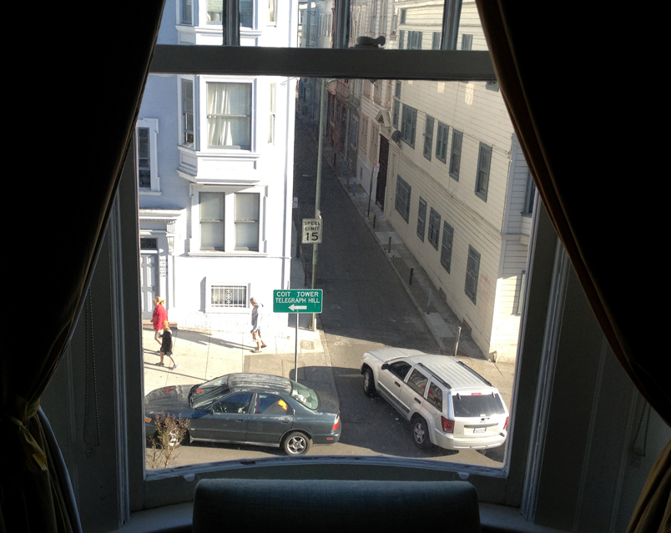
This knowledge-based interchange between working memory and long-term memory has enormous consequences for graphic design. In visual interpretation, as in speech, the most important factor in gaining rapid closure and the ability to gain new knowledge is the amount of relevant knowledge that the viewer already possesses. A visitor from the Middle Ages would not make much sense of the above view from the window.
A viewer who is familiar with the needed background knowledge, will be more likely to quickly understand the visual references in a graphic. Hence one of the trans-formal problems to be solved by a designer is to make sure that the taken-for-granted knowledge needed to understand the graphic is actually shared among the target viewers.
One needs to know at a minimum that the sign depicted below is not an entry to a theater, say, or to a conservative Jewish prayer service where men and women must be separated. Every designer is acutely aware of the importance of immediate physical context as well as shared cultural context, and their relation to tacit conventions.
Figure 8: Separation of the sexes in a restroom sign.

5 Convention and context (2): polysemy and genre
George A. Miller did foundational work in language processing as well as in immediate memory. He once observed that the initial meaning we posit for the word “shot” will be different, depending on whether the word is used on a golf course, a rifle range, or in a bar. (Miller 1999) His point has sometimes been oversimplified as exhibiting the special problem of homonyms in language – different words having the same sound: sun-son, tail-tale. But his point was far more general. All words, like all visual images, are potentially polysemous, a feature of language that enables us to convey an almost unlimited number of nuanced meanings. A certain kind of context makes likely a certain kind of meaning – the meanings that are usual or conventional to that context. Visual images in themselves are not superior to words in communication, as both depend on context for proper interpretation. Even when ‘a picture is worth a thousand words’, the viewer’s interpretation will be influenced but which words she already knows.
Different contexts: a golf course, a rifle range, a bar – all carry different conventions and meaning-expectations. The sentence “You’re a smart guy.” will have quite different overtones as praise or as a put-down. To communicate the desired meaning one has to make known which of the two genres, or contexts, or conventions is being assumed. From this we see that the terms convention, context, and genre are deeply interconnected concepts that converge on the same function, despite the polysemy of words and forms: to communicate the sort of meaning – out of several possible ones – that the writer or designer intends to stress. And all of these interconnected terms have in common the assumption of prior relevant knowledge of convention, genre, and context on the part of the viewer.
In an important book, Cognition and Categorization, (Rosch & Lloyd, 1978) Eleanor Rosch and other researchers give scientific support to the old claim from language studies that the posit of a genre is necessary to make sense of a text. Is it ironic?, is it tragic? Is it poetry or prose? are necessary questions to answer to make sense of the subsidiary parts. An overarching sense of the kind of whole that we are seeing piecemeal through our momentary window of working memory is necessary to restrict the polysemy of words, and make ongoing sense of the parts. Rosch showed that the same categorizing function is required for visual perception, both in ordinary experience and – a fortiori – in interpreting visual representations. Hence the close connections between context, convention, and genre. Context (the golf course) suggests a genre (a golf shot, not a whiskey shot) and the connection between the word shot and the actual thing is a convention of the English language.
Since meaning, whether linguistic or visual, is contingent on context and convention, the correct answer to the question: “Is there a universal practical recipe for creating good graphics?” must be an emphatic no. Cultural contingencies strongly influence the reception of any given graphic in relation to any given audience. The very form of an image is contingent upon its meaning as interpreted by an audience.
Gombrich rightly rejected as groundless the idea that certain concrete design elements will appeal to all audiences in all times and places. The very form of the design element is never a brute given but it too is a psychological construct quite as much as a verbal interpretation – something co-constructed by viewers out of their prior knowledge and expectations. This is often illustrated by the rabbit-duck phenomenon, also presented in Art and Illusion. (Gombrich, 1960: 5)
Figure 9: Rubbit or duck? One can perceive one or the other but not both at the same time.
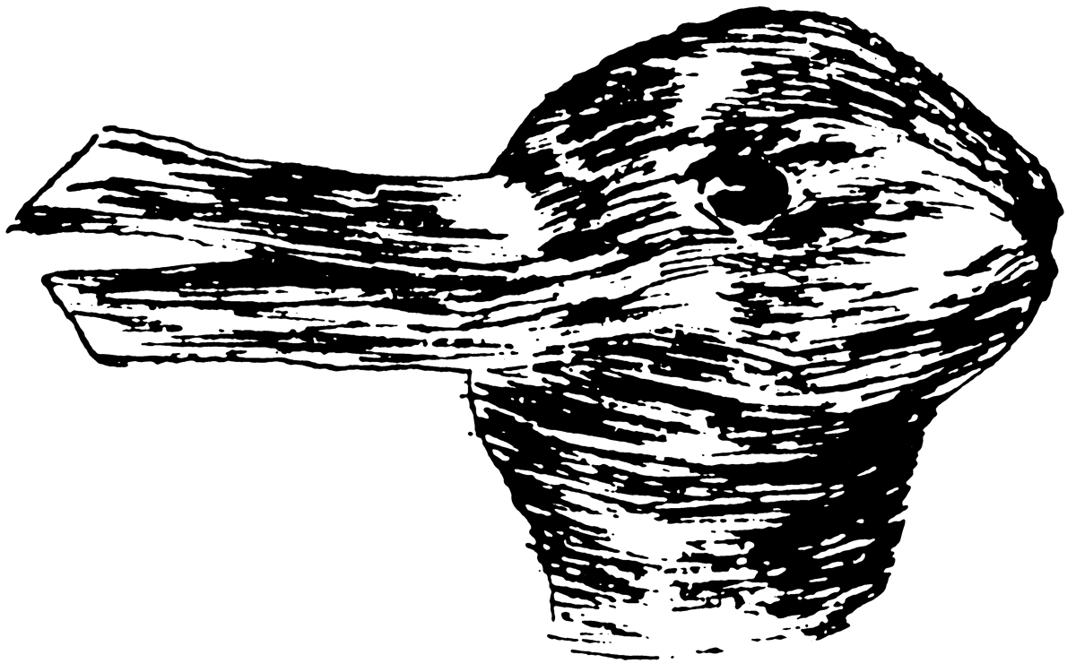

But Gombrich made the point more broadly and elegantly when he explained the naiveté of the scientists who put a design into the Pioneer Spacecraft meant to communicate something about human civilization for the benefit of beings in outer space who would lack knowledge not only of the represented objects, but also of our conventions of representation. (Gombrich, 1982: 150-151) For instance, the right side of the woman’s face is narrower than her left. What sort of lopsided creature is that?
Figure 10: Golden plaque from Pioneer 10 Spacecraft, 1972. Source: NASA, via Wikimedia commons.
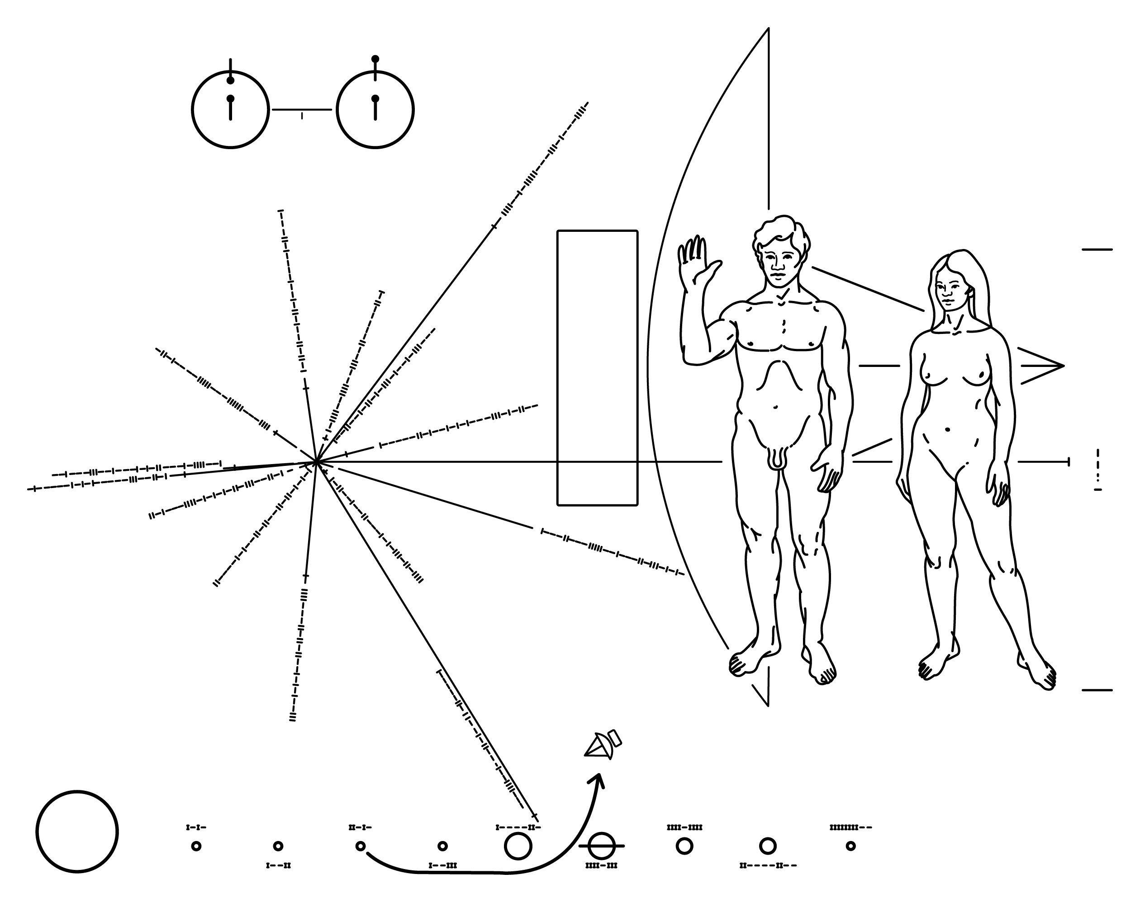

Gombrich’s observation seems so self-evident that one would have imagined NASA scientist to be a bit more logical and not assume anything. And yet they had a hard time, like most of us would, distancing themselves from the strong cultural and visual conventions of our social group, such as the use of perspective and the choice of the three-quarter view of the woman’s face, or the extensive use of diagrams. Assuming it will ever reach another being, the plaque will only work if the primary sensory mode of this unknown species happens to be the visual mode, which is by no means guaranteed. And even if aliens see this picture with something like eyes, will they infer what we take for granted based on our human experiences? Will they think that all human beings have short hair if they are male, and long hair if they are female? Will they even understand gender? The list of questions could go on and on, illustrating how visual imagery, just like verbal language, is not constituted by a set of brute givens, but becomes meaningful only after being interpreted by a real viewer who shares with the designer un-depicted knowledge and conventions.
But there were sensible limits to Gombrich’s conventionalism. There is a brute element of spatial mapping that is universal, and is not completely slave to convention. Gombrich did not present himself as an absolute conventionalist in visual design. He recognized in his great work Art and Illusion that some conventions of design such as foreshortening have an absolute basis in physics and the universal psychology of perception. Later, he pointed out that we can still interpret representations in cave drawings more than thirty thousand years old. Our perceptual systems have evolved to maneuver ourselves in space, so that we don’t run into walls. Hence our visual system must accurately map onto real space, otherwise we could not survive. So there is something absolute in our artistic mappings of spatial relations – and in the making of maps, and Gombrich had only praise for the brilliant naturalism of the 33,000-year-old drawings in the caves of Chauvet. (Gombrich, 1996) But he also placed strict limits on this concession to naturalism. Universally meaningful forms are exceedingly rare, and cannot constitute a workable basis for the historian or the designer.
6 Convention and context (3): perception as construction
Cognitive science is thus telling us that our interpretation of a graphic or a text is highly dependent on elements in long-term memory that are not given in the graphic. The interpretation of what is seen is dependent upon unstated prior knowledge in long-term memory. The brief span of working memory is the site where this unification of the present with the past takes place if the present experience is to have any meaning at all. Hence all meaningful perception is not simply reception; it is also construction. The concept of construction is thus another approach to the insight that no form is given or monosemic.
The understanding of the constructive character of perception and memory can be traced back to F. C. Bartlett’s pioneering work on memory: Remembering: A Study in Experimental and Social Psychology (Bartlett, 1932) in which he showed that a person’s recollections are highly influenced by that person’s personal history and knowledge. He termed this phenomenon the social dimension of remembering: what we already know will determine our perceptions.
The prior knowledge that influences our present perception is thus just as important to the effectiveness of design as the stringent temporal bottleneck of working memory, and greatly helps overcome that bottleneck. The more quickly accessible that relevant knowledge is, the more rapidly closure can be achieved. Cognitive scientists therefore lay great stress on the concept of accessibility. (van der Helm & Leeuwenberg, 1991) It’s up to the designer to invoke quickly accessible, that is, familiar, knowledge among the target viewers. While neither the designer nor the reader can modify the general time limitation of working memory, both can employ strategies to minimize its effects and maximize communication by adding enough familiar elements to provide accessible scaffolding that aids the viewing or learning process – titles, captions, labels, etc. – so that the material is interesting and challenging, but still approachable to the viewer. Amanda Cox, graphics editor of The New York Times, has termed this type of accessible scaffolding the annotation layer of a graphic. (Cox, 2012)
An anatomical sketch by Leonardo da Vinci shows just how important this annotation layer is, even when the graphic is not intended for public viewing. Leonardo no doubt understood the limitations of his own memory and made sure to record his immediate observations in a more permanent way.
Figure 11: Leonardo da Vinci, Studies of embryos, c.1510-13. Pen over Red Chalk, 12 x 8 inches (30.5 x 20 cm). Royal Library, Windsor Castle, via wikimedia commons.
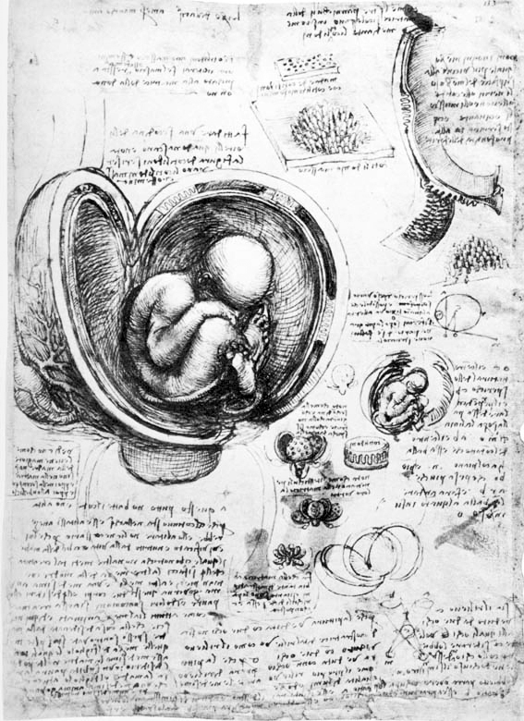

We can see this layer at work in a NY Times graphic about driving safety, (Fairfield, 2012) which depicts the decline in traffic fatalities in the United States in recent decades. In the graphic, a segmented line connects various dots representing the years from 1950 to 2011. Each dot’s position is determined by the number of miles driven per capita in that year (the horizontal X axis) and by the number of fatalities per 100,000 people in that year (the vertical Y axis). The title of the piece: Driving safety, in fits and starts is direct and yet intriguing, and sets the tone for the other textual and visual elements that can be managed as secondary, smaller individual chunks.
Figure 12: Hannah Fairfield: Driving safety, in fits and starts. The New York Times, September 17, 2012 – web page version of printed article. Source: The New York Times, 2012..
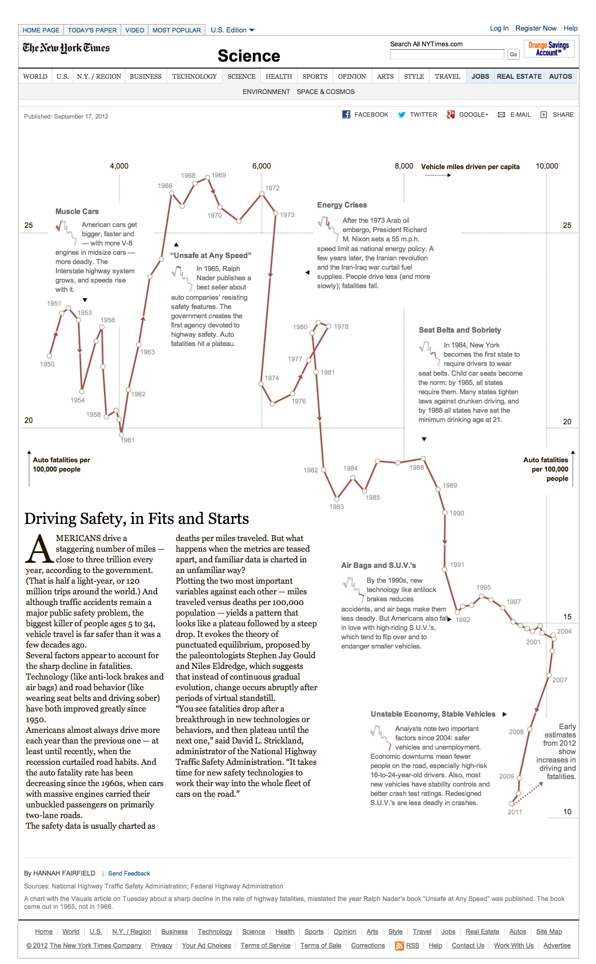

In summary, the conventional dimension of perception – the relevant knowledge in long-term memory that influences our present perception – is just as important as the stringent temporal bottleneck of working memory, and is the chief means of overcoming that bottleneck. While neither the designer nor the reader can modify the general time limitation of working memory, both can employ strategies to minimize its effects and maximize speed of communication. The communicative task of effective graphic design is summed up in that sentence.
7 The theoretical significance of Minard’s map
In the many pages that Jacques Bertin devotes to maps in his monumental Semiology of Graphics, nowhere do I find illustration or mention of what Edward Tufte (2006) considers to be the best, most pathbreaking map in the history of graphic design: “Carte figurative des pertes successives en hommes de l’Armée Française dans la campagne de Russie 1812-1813”, or “Figurative Map of the successive losses in men of the French Army in the Russian campaign of 1812-13”, drawn by the French engineer Charles Minard in 1869:
Figure 13: Charles Minard’s map of the Russian campaign of 1812-13. From Tableaux graphiques et cartes figuratives de M. Minard, 1845-1869, Bibiothèque de l'École nationale des ponts et chaussée, Paris (62.4 x 24.5 cm or 24.5 x 9.6 inches).
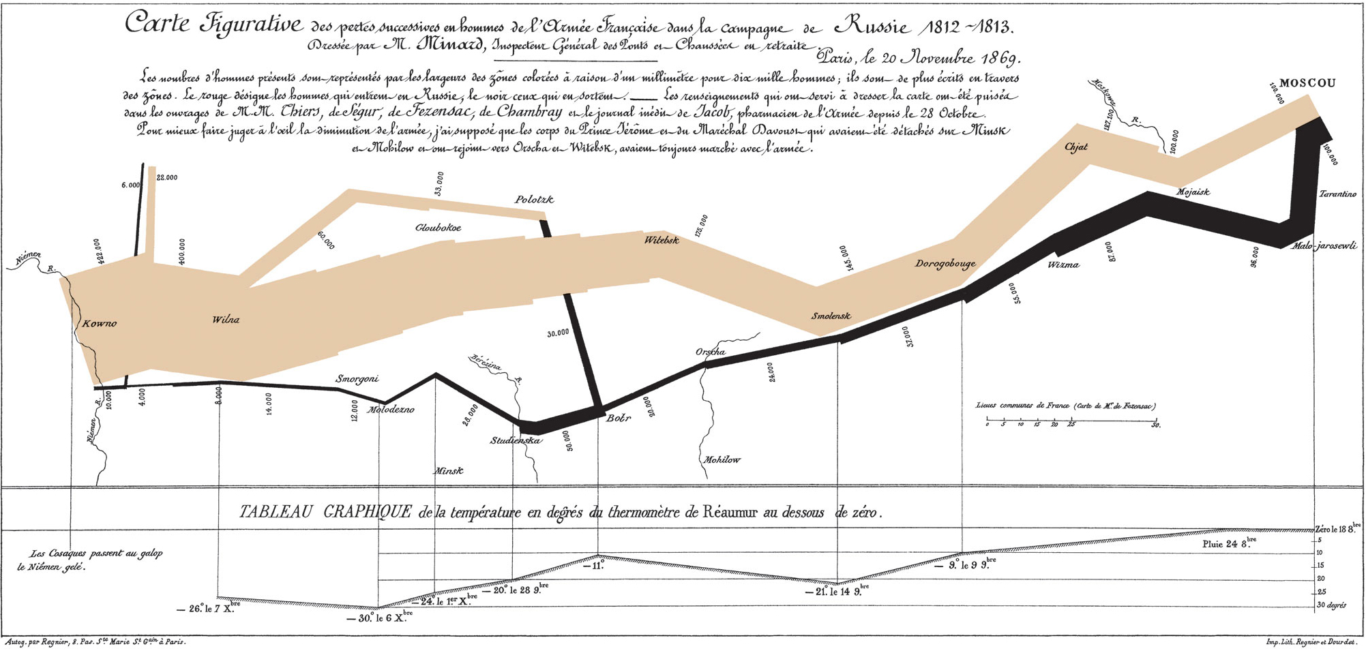

Why this remarkable omission? One reason may be that Bertin has other fish to fry, and this remarkable achievement of his compatriot does not fit into his scheme. Bertin is interested in graphic givens, in the immediate perceptual effects of definite forms, whereas Minard’s perceptual effects are anything but immediate. Although Bertin is aware of the temporal dimension and its relation to memory, even pointing out that ‘a shorter observation time’ (Bertin, 1983: 139) makes a graphic construction more efficient, he tends to assign a ‘natural and immediate perception’ to the relationships among the three dimensions X Y Z (Bertin, 1983: xiv) that is far from being an immediate given, thus chasing the mirage that questions can be answered ‘in a single instant of perception […] IN A SINGLE IMAGE.’ (Bertin 1983: 146) By contrast, Minard’s graphic constructions are completely dependent for their interpretation on a large quantity of relevant background knowledge stored in long-term memory. Thus, Minard’s achievement is an excellent example and confirmation of the general cognitive principles enunciated here.
In the diagram of the Russian campaign our normal idea of a map will be challenged immediately because the picture only vaguely resembles a map. And so it will take some time and effort to accept the varying thickness of a path – the colored line – as a statistical representation of the number of soldiers who are still alive at any point in the campaign. But as soon as that visual link between the line (the encoding) and the soldiers (the decoding) is established, we have no difficulty in sustaining it, and the abstract character of the line is no obstacle to the concrete understanding of the graphic and the appreciation of the story. Yet none of these meanings would come to fruition if the map were presented to a person – say a typical American 4th-grader who had never heard of Napoleon or the Russian campaign. Minard could assume among his countrymen a tremendous number of associations which make these simple flow lines pregnant with meaning – and emotion!
But technically speaking, why use a line, a path of changing thickness to represent the thinning number of soldiers? Of course other means could be used to visualize that numerical variable, but why is this particular device so successful in aiding the viewer to make the connection and understand the graphic? How does the line work as a vivid representation of the data? Although a thorough technical analysis of the map was performed by Leland Wilkinson in The Grammar of Graphics (Wilkinson, 2005, pp. 623-629) I suggest a humble ancestor of Minard’s changing line: the bar chart, invented by William Playfair, which made its first appearance in his Commercial and Political Atlas, published in London in 1786. Minard’s line is at the core a simple bar chart sorted and ordered by value (survivors) from highest to lowest, left to right until it reaches Moscow, and right to left on the journey back. In the lower portion depicting the retreat the line even resembles a bar chart, while in the advance depicted at the top the line looks like an old-fashioned telescope. Strictly speaking, the line is formed by a series of bars that have been joined together and aligned at their midpoint – especially in the top portion – instead of at the base, giving the figure its symmetrical, line-like quality. A century earlier Playfair had used the thickness of a path to represent a variable (Wilkinson, 2005), but Minard seems to have deliberately glued together Playfair’s bars to create his very informative graphic. Various other graphs by Minard show connected bars of different width and height, indicating that he had used the technique several decades earlier. (Friendly, 2001)
Figure 14: Minard’s line as a sequence of connected bars aligned at their midpoint.
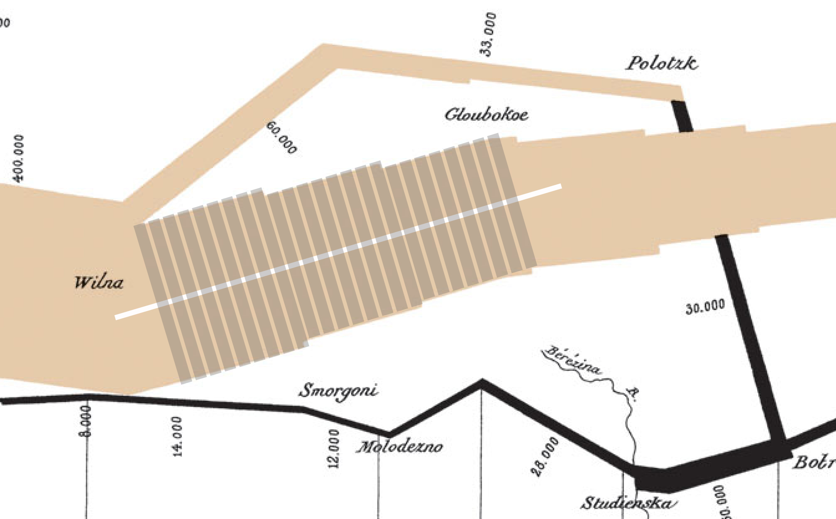

The graphic encoding of the changing thickness of the line – a colored area stands for a set of changing numbers – representing the diminishing size of the French army is a type of convention that is outside of the actual picture. It would not be possible to represent the multitude of dying soldiers in a figurative way on a single page without the risk of losing the broad view in favour of many unnecessary details. The single page diagram is so economical in its clarity that all external references occur outside of the page and in the mind of the viewer – thanks in part to the explanation of the encoding system that is printed directly under the title.
In addition to the size of the army variable, Minard’s construction meshes together several other variables, forming an integrated and beautiful statistical graphic reminiscent of an aerial view of the Great Wall of China. The path is a visual abstraction depicting the size of the army over time but its effect is very tangible as it represents real people and real deaths. The path’s changing orientation looks like a road trip marked on a map, a well-annotated map that includes various names of rivers and cities. Finally, the graphic is clearly introduced by the title, and the subtitle that explains in detail the pictorial conventions employed by the author.
8 The two New York subway maps
Between 1979 and 2012 the current map has undergone mainly superficial changes, but the underlying structure has remained intact: an analogical representation of the network of train lines combined with the basic layer of streets, parks, and rivers. In these maps geography trumps geometry. While the 1972 map did not add any details to the subway train lines, the 2012 map includes all kinds of information: above-ground train lines, tunnels, parks, streets, airports, cemeteries, etc. All things belonging to the real world, the one that the average user is trying to navigate. These basic elements that are familiar to the user will make it easier for him to understand the map: rich detail and complexity of representation will translate into simplicity of communication.
Figure 15: The New York Subway map, as reprinted in 1978. Source: author's collection, 2012.
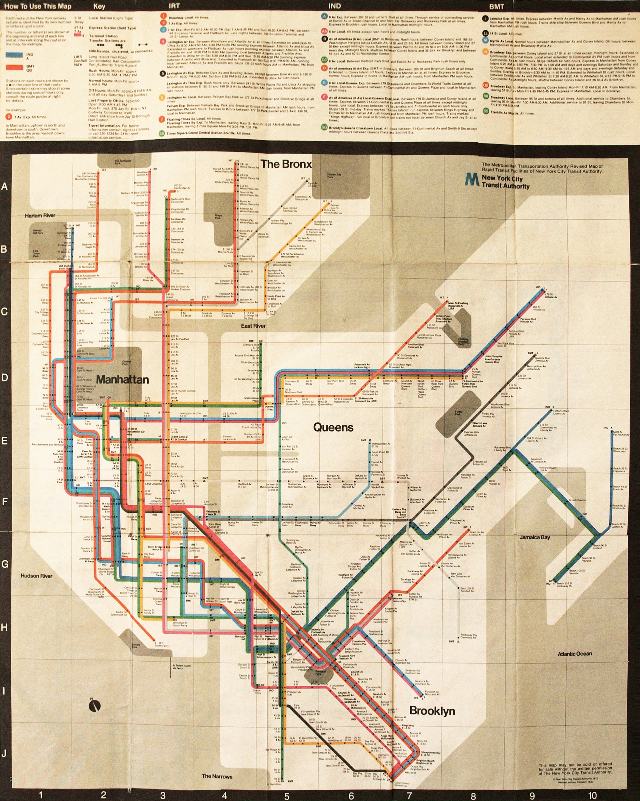

Figure 16: The New York Subway map in 2012, based of the 1979 redesign by Michael Hertz. Source: MTA web site, New York City, 2012.
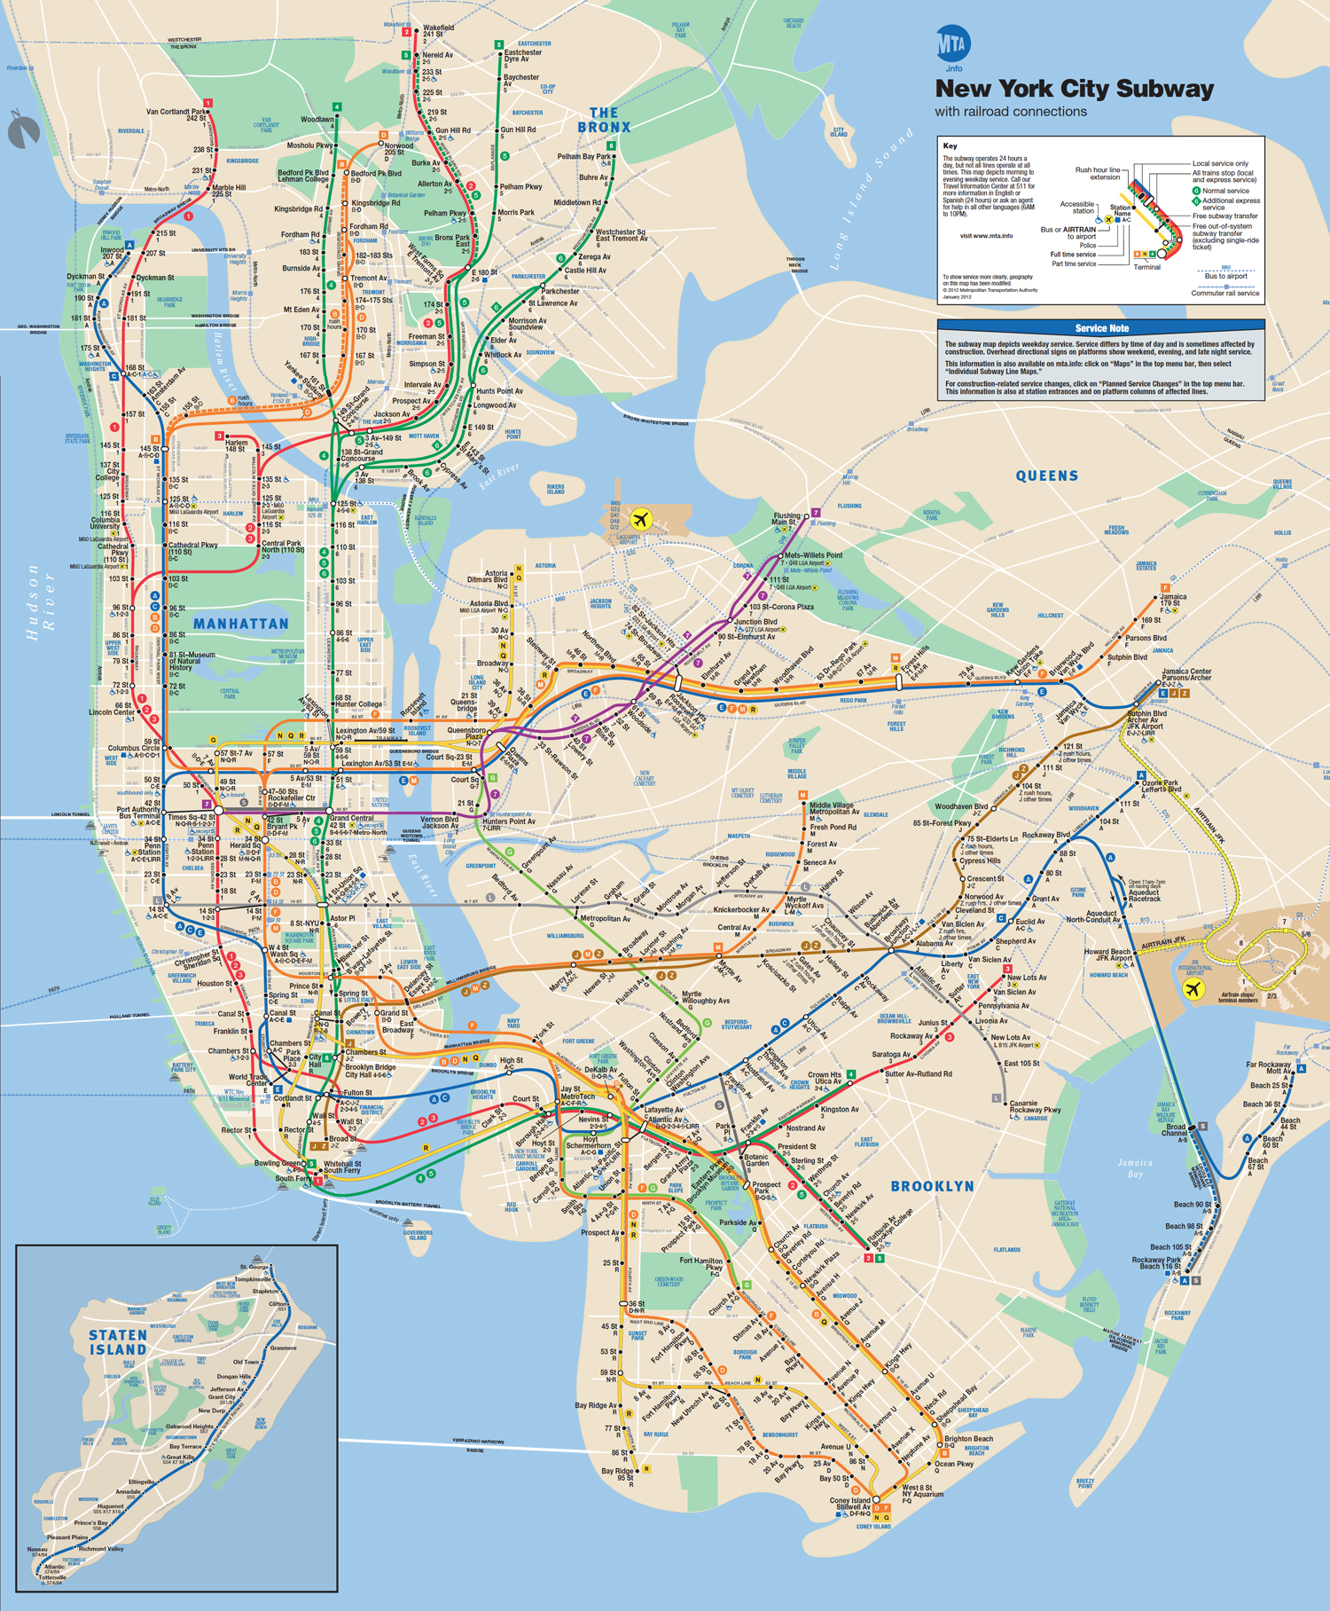

Ask a three-year old from a small rural town which of these two pictures she prefers, and the answer might well be the abstract Vignelli – depending on whether she likes straight lines rather than curves. My own aesthetic preference is for the new map, but if beauty loves the fulfillment of pattern expectations, then the repeating patterns in the Vignelli are very likely to please. Moreover, once one gets used to the Vignelli convention of focusing on the rail system itself rather than the underlying geography which supports it, one could very well make one’s way in New York with it, just as one does in Paris, which uses somewhat similar schematisms which emphasize the rail system more than the underlying topography:
Figure 17: Paris metro, detail. Screen shot from RATP web site (Régie Autonome des Transports Parisiens). http://www.ratp.fr/plan-interactif/carteidf.php?lang=uk
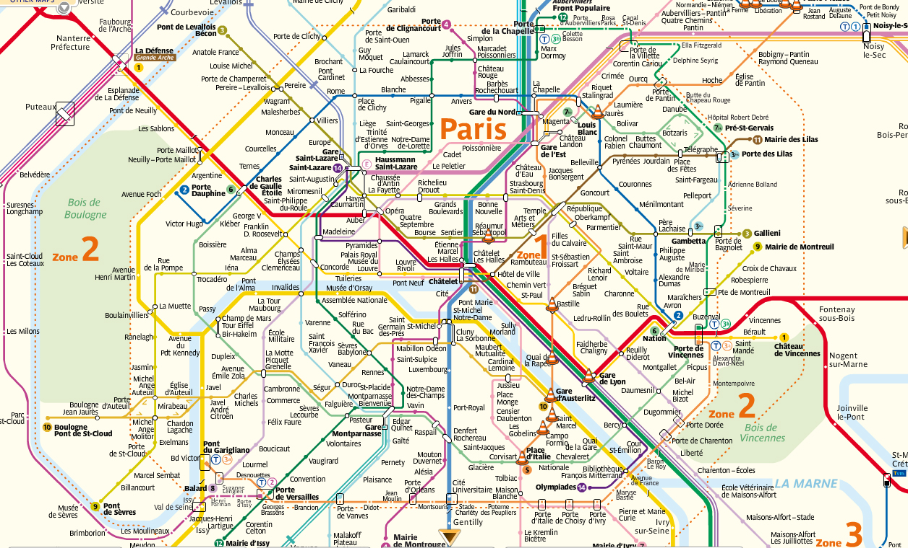
Or in London:
Figure 18: London underground, detail. Transport for London web site, detail from dowloadable PDF. http://www.tfl.gov.uk/
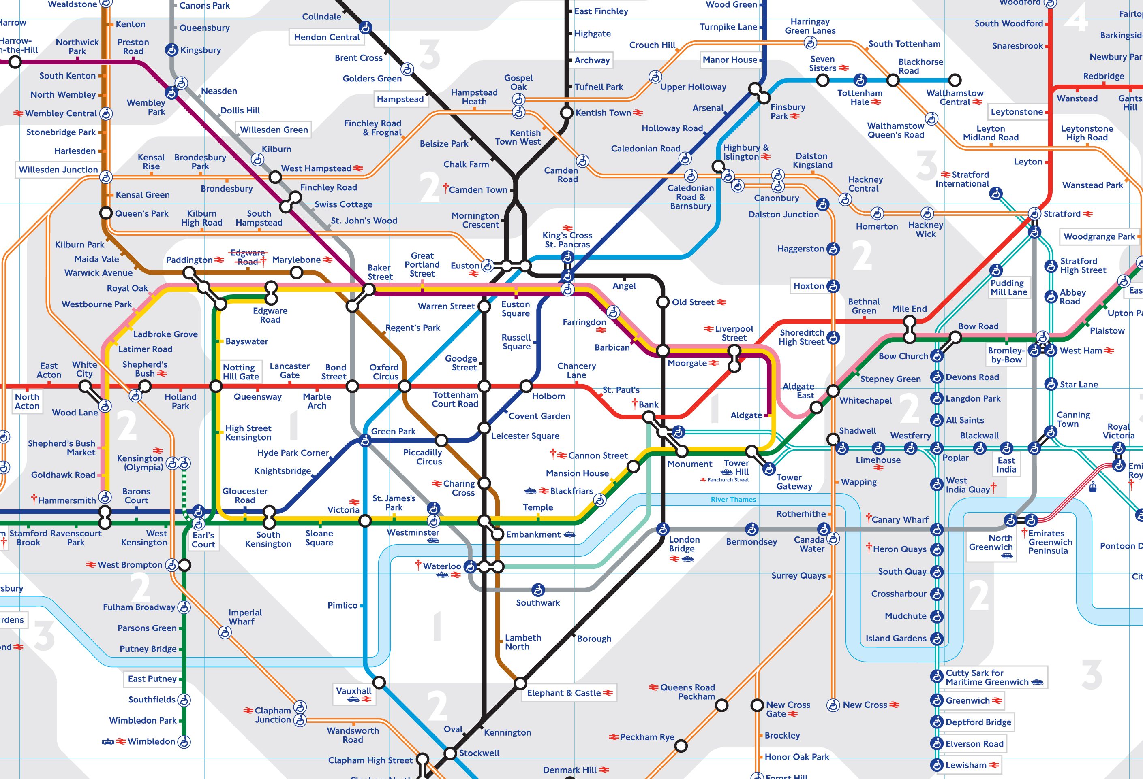

This London map essentially reproduces Beck’s original design of 1931, making it a durable 82 years old and still going strong. Here’s the very relevant comment in the article on Beck in Wikipedia:
He believed that passengers riding the Underground were not too bothered about geographical accuracy, and were more interested in how to get from one station to another and where to change trains. Thus Beck drew his famous diagram, which looked more like and indeed was based upon the concept of an electrical schematic than a true map, on which all the stations were more-or-less equally spaced. Beck first submitted his idea to Frank Pick of London Underground in 1931, but it was considered too radical because it didn't show distances relative from any one station to the others. The design was therefore rejected by the Publicity department at first, but the designer persisted. So, after a successful trial of 500 copies in 1932, distributed via a select few stations, the map was given its first full publication in 1933 (700,000 copies). The positive reaction from customers proved it was a sound design, and a large reprint was required after only one month. (Wikipedia, 2013)
Why then, did the abstract schematic in London and Paris succeed, while Vignelli’s failed? Let’s see if the theoretical considerations brought forth in this essay can explain the difference – which the illustrations show is a matter of degree rather than of kind. We know that a schematic, topologically incorrect map can work, and indeed has continued to work for tens of millions of passengers in London and Paris. But New York City – an island-ocean-and-river city – is topologically different. In a river city, like London or Paris surrounded by flat suburbs, one needs only a schematic representation of the river for general orientation. The rest is flat land area, and if that area is lengthened or foreshortened a bit here and there, one still feels oriented in space.
The underlying topography of Manhattan Island and its surrounding boroughs is far less simple geographically and psychologically than the topography of Paris and London. And to compound the problem, Vignelli’s version of a schematic representation essentially leaves out all reference to topographical reality. He imposes an imaginary white flat-land area on a very complex water-and-land mix, making it hard for a passenger to imagine where he is in space. We are always looking for that “You Are Here.” spot on a map, and when we can’t find it we become uncomfortable and anxious. The urban planner Kevin Lynch understood the importance of one’s mental image of a place and in his book The Image of the City he underscored the psychological aspects of perception and memory involved in spatial orientation:
In the process of way-finding, the strategic link is the environmental image, the generalized mental picture of the exterior physical world that is held by an individual. This image is the product both of immediate sensation and of the memory of past experience, and it is used to interpret information and to guide action [italics added]. The need to recognize and pattern our surroundings is so crucial, and has such long roots in the past that this image has wide practical and emotional importance to the individual. (Lynch, 1960: 4)
Therefore one can put the difference between Vignelli’s map and the London and Paris maps in terms of conventions and expectations derived from past experience. The primary learned convention of map reading is isomorphism – meaning that any area on the map has a corresponding area on the earth, with accurate relative magnitude and direction in relation to other represented areas. This process has been used for centuries by cartographers throughout the world and has been picked up by cognitive-minded industrial designers. They termed this isomorphism natural mapping, and applied it to the intuitive arrangement of control knobs, levers and switches on devices as diverse of stovetops, airplane cockpits, and car doors. (Norman, 1988: 75-80)
Figure 19: The control knobs in this stovetop are naturally mapped to the corresponding burners, requiring very little cognitive load to perform the desired action. (Needs source)
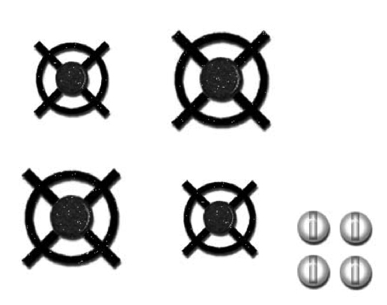

This isomorphism is obvious on an ordinary automobile map. If I point the map in the direction I am going, then my progress on the earth and my progress as traced on the map will stay in relation. This isomorphic relation is stretched, but not abandoned In the London and Paris subway maps. In the Vignelli map, by contrast the isomorphic relations are stretched so far that viewers can’t map even approximately their positions on earth with their imagined positions on the map.
This defect would not matter if, psychologically, passengers just cared about going from A to B on the subway system. But if they were schooled in map conventions, and if they were used to the convention of isomorphism relating their position on earth to their position on the subway map, it would make a very big difference to them psychologically, because their expectations would be defeated, resulting in confusion and disorientation, which is just what the New Yorkers complained of with the Vignelli map. The New Yorkers were too knowledgeable; they knew too much about isomorphic map conventions and New York geography. The defeat of their expectations and assumptions caused massive confusion.
It was Vignelli’s fault. Good graphic designers cannot, must not ignore or thwart the conventions and expectations of their viewers. The London and Paris maps had at least schematic representations of the Seine and Thames rivers, and that was all the vaguely-isomorphic spatial orientation the passengers seemed to require to fulfill their genre expectations. In Vignelli’s effort, there isn’t a hint of water anywhere – odd for an island city. A faint point of reference to topographical reality is Central Park which he confusingly converts from a rectangle to a square. One could hardly invent a better example of the designer’s failure in the primary requirement to acknowledge and work with the design’s context – the knowledge, conventions, and expectations of viewers.
9 Conclusion
Methods and skills alone will never provide a universal recipe for good design, and there will be no formula that will work in all places and all times. Maxims such as form follows function, less is more, or similar generic statements as make the complex simple and too much information are equally useful or useless depending on the specific context at hand. Often a beautiful and simple image can be disappointingly uninformative, or an elaborate and complex image can be psychologically simple and beautifully informative. The Vignelli subway map confirms that graphic formulas can fail in the face of common sense and practicality. One might insist that the Vignelli map is very beautiful and of course it is beautiful, but would one describe as ugly the subtle, deep layers of details included in the redesigned map of 1979? That such complexity can be very satisfying is proven by the fact that the inclusion of those street names, rivers, parks, and other urban elements has survived the test of time up to the current updated version of 2012.
The cognitive limitations of working memory are always at work in perception and so are the conventional constraints of the viewer’s background knowledge and familiarity with the topic. This process takes place irrespective of the visual style or genre carrying the content. Therefore an awareness of the constraints of cognition, context, and convention should constitute the basis of any methodology that already includes traditional skills such as layout design, typography, and color theory. It should also be the basis for methodologies advocating specific design processes, whether these are called sustainable design, design thinking, experience based, or whatever the latest design buzzword is. Good design can and will occur sometimes also in the absence of a conscious appreciation of the psychological process, but when the specific methods and skills are applied in the context of the general constraints of convention, context, and cognition, then the practical will reinforce the theoretical and vice-versa.
In an interesting digital twist, the 1972 Vignelli map has made a comeback in an interactive web version called The Weekender (Heller, 2011) which provides real-time information about outages in the system. Given the interactive nature of this implementation, the spare geometry of the design could be seen as an advantage – especially among a new generation of riders living in a virtual world who may have rather vague preconceptions about the geography around them, and may not have confusion-inducing prejudices about the actual shape of Central Park. Whatever the expectations and conventions of this new generation, and new era, it will be the task of graphic designers to accommodate themselves to those shared assumptions and expectations. For graphic design is not a timeless art, important as its timeless craft-like may be. Graphic design, like poetry and prose, is a cultural, communicative artifact of its own time and place.
Acknowledgements
My heartfelt gratitude goes to E.D. Hirsch, Jr., whose intellectual insight and erudition have guided me throughout the writing of this essay. To him I owe many of the germinating ideas that have been developed into the overall concepts presented here. Whatever clarity I hope I have achieved in this essay, I owe to his many constructive suggestions that followed various critical readings of the manuscript.
Bibliography
BADDELEY, A. D. 1999. Essentials of human memory. Hove, UK: Psychology Press.
BARTLETT, F. C. 1932. Remembering: a study in experimental and social psychology. Cambridge: Cambridge University Press.
BERTIN, J. 1983. Semiology of graphics. Madison, WI: The University of Wisconsin Press.
BUTTER, C. M. 2011. Crossing cultural borders universals in art and their biological roots. CreateSpace.
CASSIRER, E. 1953. The philosophy of symbolic forms. (R. Manheim, Trans.) New Haven, CT: Yale University Press.
COX, A. 2012. Eyeo2012 - Amanda Cox. In: Vimeo. <https://vimeo.com/45537437>, 10/07/2012.
DE SASSURE, F. 1959. Course in general linguistics. (W. Baskin, Trans.) New York: Philosophical Library.
FAIRFIELD, H. 2012. Driving safety, in fits and starts. In: Driving safety, in fits and starts - Graphic - NYTimes.com: <http://www.nytimes.com/interactive/2012/09/17/science/driving-safety-in-fits-and-starts.html>, 09/17/2012.
GEARY, D. C., Bow-Thomas, C. C., Liu, F., & Siegler, R. S. 1996. Development of arithmetical competencies in Chinese and American children: influence of age, language, and schooling. Child Development , 67 (5), 2022-2044.
GEICO, 2012. The gecko journey commercials, The Martin Agency. In: youtube.com: <http://www.youtube.com/playlist?list=PL48CEA17B9558F0B7>, 18/09/2012.
GOMBRICH, E. H. 1960. Art and illusion: a study in the psychology of pictorial representation. Princeton: Princeton University Press.
GOMBRICH, E. H. 1982. The image and the eye: further studies in the psychology of pictorial representation. Oxford: Phaidon.
GOMBRICH, E. H. 1996. The miracle at Chauvet. In: The New York Review of Books. <http://www.nybooks.com/articles/archives/1996/nov/14/the-miracle-at-chauvet>, 14/11/1996.
HIRSCH, JR., E. D. 1977. The philosophy of composition. Chicago, IL: The University of Chicago Press.
LESSING, G. E. 1962. Laocoön; an essay on the limits of painting and poetry. (E. A. McCormick, Trans.) Indianapolis, IN: Bobbs-Merrill.
LOGIE, R. H. 1996. The seven ages of working memory. In J. T. Richardson, L. H. Robert, E. R. Stoltzfus, L. Hasher, R. T. Zacks, & R. W. Engle, Working memory and human cognition: 31-65. New York: Oxford University Press.
LOYD, P. B., & OVENDEN, M. 2012. Vignelli transit maps. Rochester, New York: RIT Cary Graphic Arts Press.
MILLER, G. A. 1956. The magical number seven, plus or minus two: Some limits on our capacity for processing information. Psychological Review, 63 (2), 81-97.
MILLER, G. A. (1999). The Magical Number Seven, Plus or Minus Two: Some Limits on Our Capacity for Processing Information. Psychological Review , 63 (2), 81-97.
MINARD, C. J. 1869. Tableaux Graphiques et Cartes Figuratives de M. Minard, 1845-1869. Paris: Bibliotèque de l'École Nationale des Pontes et Chaussées.
NOIZET, G., & PYNTE, J. 1976. Implicit labelling and readiness for pronunciation during the perceptual process. Perception, 5 (2), 217–223.
PLAYFAIR, W. 1786. Commercial and political atlas: representing, by copper-plate charts, the progress of the commerce, revenues, expenditure, and debts of England, during the whole of the eighteenth century. London: Corry.
ROSCH, E., & LLOYD, B. B. (Eds.). 1978. Cognition and categorization. Hillsdale, N.J.: Erlbaum.
SELLARS, W. 1956. Empiricism and the philosophy of mind. In: E. Feigl , & M. Scriven (Eds.), Minnesota studies in the philosophy of science, Volume I: The foundations of science and the concepts of psychology and psychoanalysis: 253-329. Minneapolis, MN: University of Minnesota Press.
TUFTE, E. R. 2006. Beautiful Evidence. Cheshire, CT: Graphics Press LLC.
VAN DER HELM, P. A., & LEEUWENBERG, E. L. 1991. Accessibility: a criterion for regularity and hierarchy in visual pattern codes. Journal of Mathematical Psychology, 35, 151-213.
WARE, C. 2008. Visual thinking for design. Burlington, MA: Morgan Kaufmann.
WILKINSON, L. 2005. The grammar of graphics. New York: Springer.
WILLINGHAM, D. T. 2009. Why don't students like school? A cognitive scientist answers questions about how the mind works and what it means for the classroom. San Francisco: Jossey-Bass.

